**Gagan Kumar Soni**

**College Roll No. 0814**

**Examination Roll No. 19035570036**

**Bsc Computer Science Hons. 3rd Years Section A**

1.Display your systems IP Address, Subnet mask using ipconfig, and find out the network address and the maximum number of systems possible on your network and range of IP addresses available to these systems.

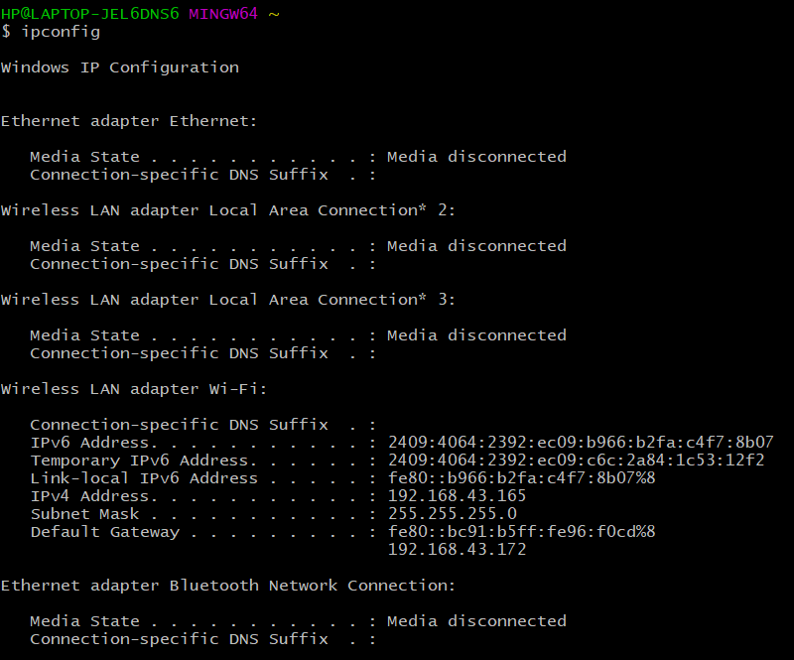

**● System IP Address: 192.168.43.165**

**● Subnet mask: 255.255.255.0**

**● Network ID: 192.168.43.0**

**● Broadcast ID: 192.168.43.255**

**● Maximum number of system possible on the network: 254**

**● Range of IP addresses: 192.168.43.0 to 192.168.43.255**

**● Class type: C**

2.With help of ping, check if you are connected to other systems of your network and find the route to connect to that system using tracert. List all the processes which are using ports for TCP protocol.

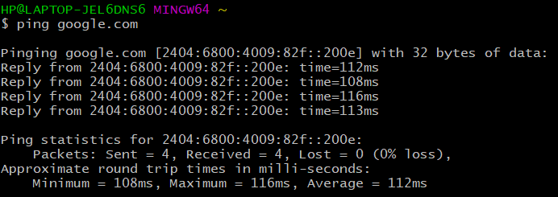

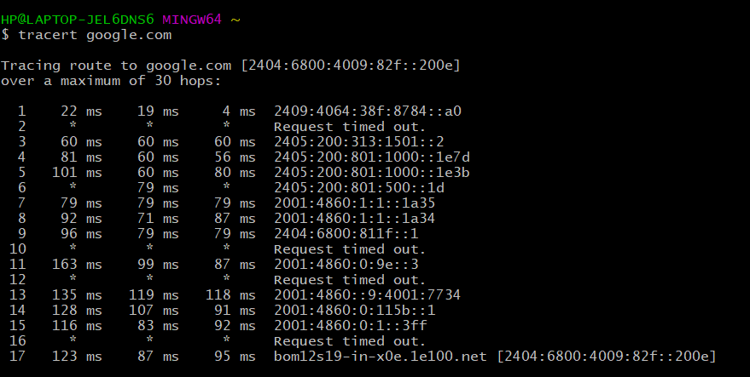

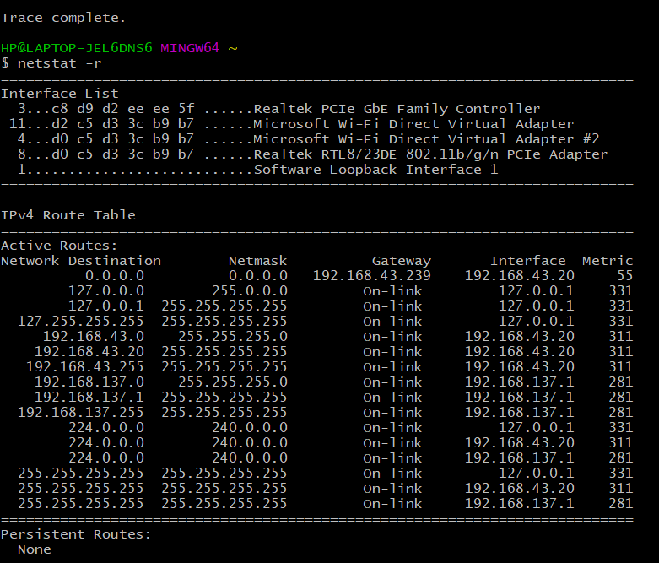

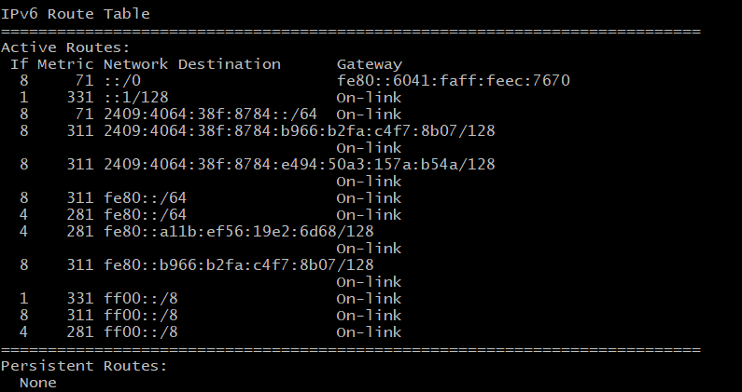

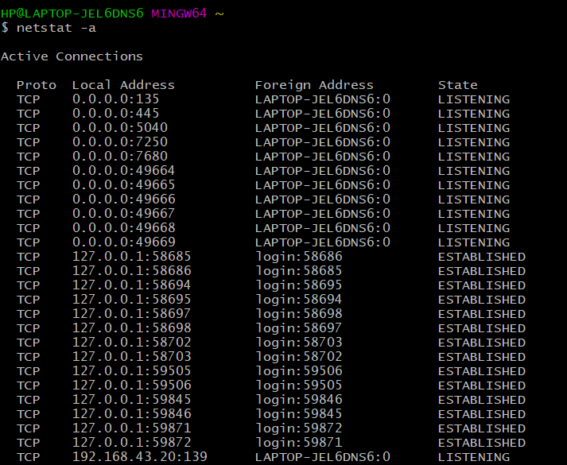

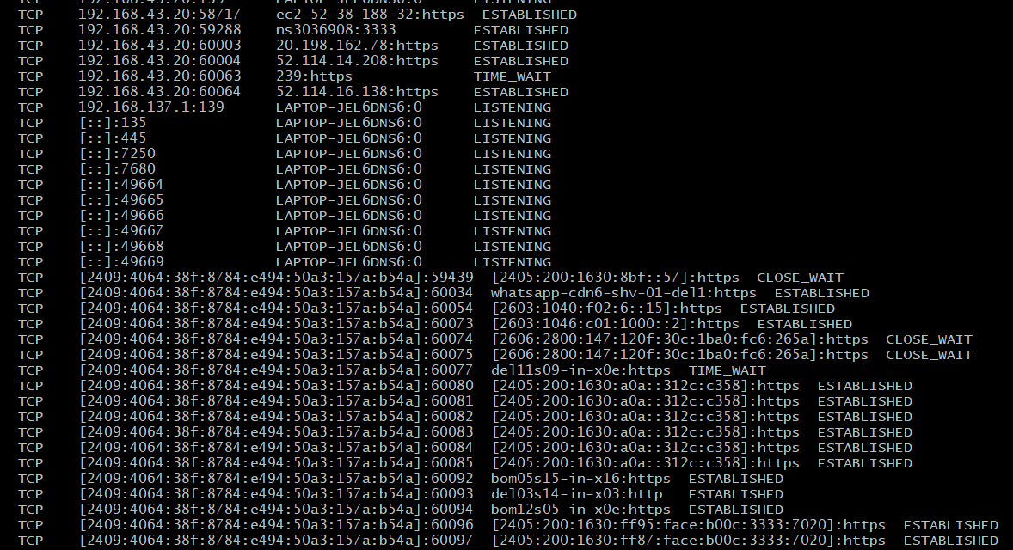

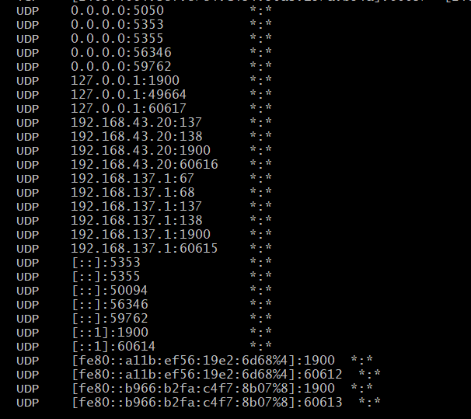’

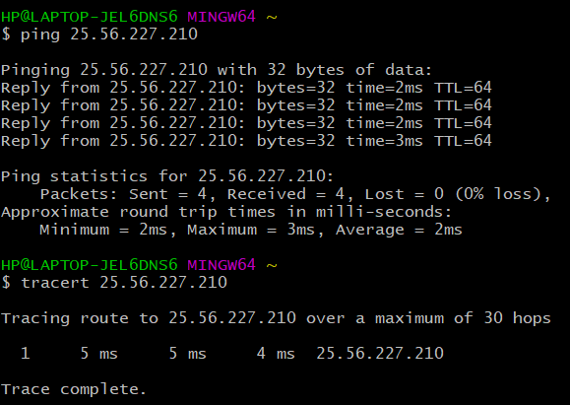

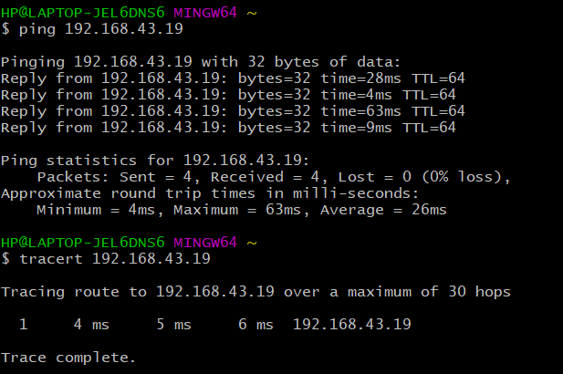

3. Create an HTML page that shows information about you, your course, hobbies, address, and your plans. Use CSS for styling of HTML page so that looks nice.

<!DOCTYPE html>

<html>

<head>

<title>Practical 3</title>

<meta charset="utf-8">

<meta name="viewport" content="width=device-width, initial-scale=1.0">

<style type="text/css">

*{

}

body{

background: grey;

}

.container{

width: 30%;

min-width: 330px;

margin: auto;

margin-top: 10px;

margin-bottom: 10px;

background-image: url('https://encrypted-tbn0.gstatic.com/images?q=tbn:ANd9GcRgilZbOsXfG-KH8r99d0OKXkX9NI9Nyi-k5g&usqp=CAU');

background-size: contain;

border: 1px solid black;

padding: 10px;

border-radius: 8px;

}

.my-5{

margin-top: 5px;

margin-bottom: 5px;

}

.underline{

text-decoration: underline;

}

.main{

display: flex;

flex-wrap: wrap;

}

.sub-head{

font-weight: bold;

}

</style>

</head>

<body>

<div class="main">

<div class="container">

<h1 class="my-5 underline">Gagan Kumar Soni</h1>

<p>Bsc. Computer Science Hons.</p>

</div>

<div class="container">

<p>

<span class="underline sub-head">Hobbies:</span>

<span> Debugging, Travelling, Coding, Table-Tennis</span>

</p>

<p>

<span class="underline sub-head">Address:</span>

<span> Basti more, Near Sher shah suri tomb, Sasaram, Rohtas, Bihar-821115</span>

</p>

</div>

<div class="container">

<p>

<span class="underline sub-head">Plans: </span>

<ul>

<li>To be a great Enterpreur</li>

<li>To find something innovative in the field of technology</li>

<li>Better world for all</li>

</ul>

</p>

</div>

</div>

</body>

</html>

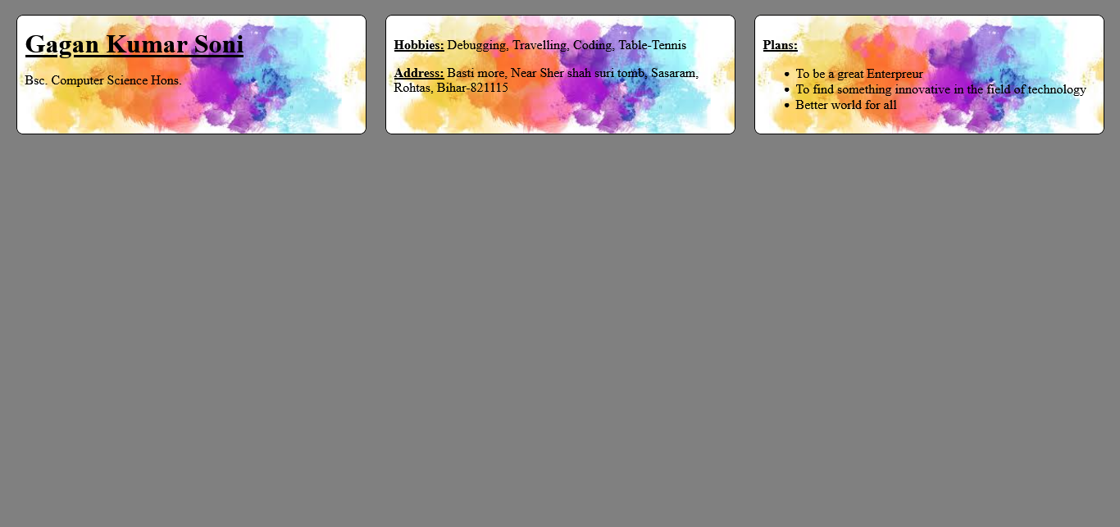

4.Create an HTML page with the sole purpose to show multiplication tables of 2 to 10 (row-wise) created by JavaScript. Initially, the page is blank. With help of setInterval function print a row every 5 seconds in different colors and increasing font size.

<!DOCTYPE html>

<html>

<head>

<title>Practical 4</title>

<meta charset="utf-8">

<style type="text/css">

table{

border: 1px solid black;

border-collapse: collapse;

width: 80%;

margin: auto;

}

td,th{

border: 1px solid black;

padding: 5px;

/border-collapse: collapse;/

}

.center{

text-align: center;

}

</style>

</head>

<body>

<h1>Printing Table from 2 to 10</h1>

<table class="center" id="content">

</table>

<script type="text/javascript">

function getRandomColor() {

var letters = '0123456789ABCDEF';

var color = '#';

for (var i = 0; i < 6; i++) {

color += letters[Math.floor(Math.random() * 16)];

}

return color;

}

var tbl = document.getElementById('content');

var number = 2;

var abc = setInterval(printrow,5000);

function printrow(){

if (number == 10)

{

clearInterval(abc);

}

var result = "";

for(var i = 1; i<= 10; i++){

result = result + "<td>"+ number + "*" + i + "=" + number * i+"</td>";

}

number++;

var row = document.createElement('tr');

row.style.color= getRandomColor();

row.style.fontSize = (number+10)+"px";

row.innerHTML=result;

tbl.append(row);

}

</script>

</body>

</html>

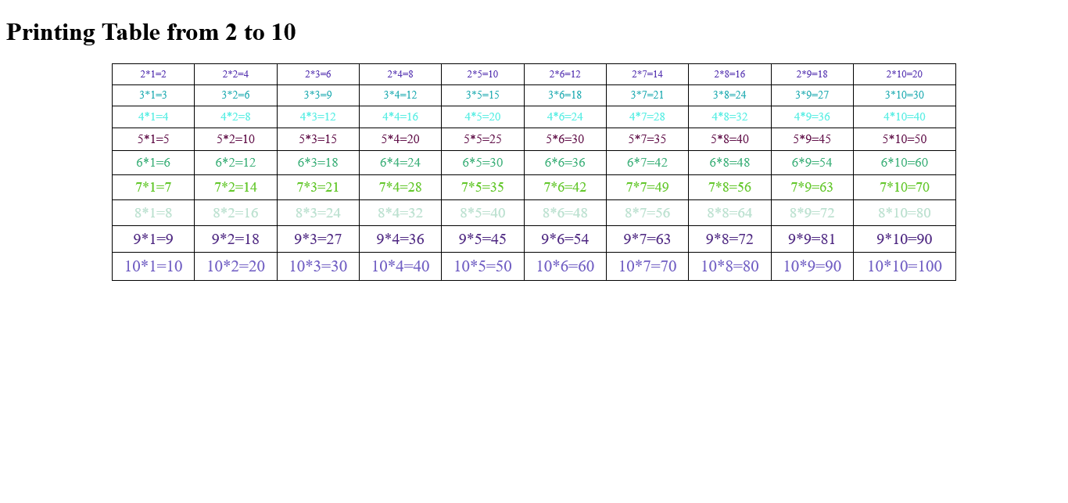

5.Create an HTML page with a paragraph written on it and under which 9 buttons are placed in a 3X3 grid. The first row is for buttons labeled with colors names Red, Green, and Blue, the second row with numbers 10, 20, 30, and the third row with different font names. Click event of each of the buttons should make the appropriate change in the style of paragraph.

<!DOCTYPE html>

<html>

<head>

<title>Practical 5</title>

<meta charset="utf-8">

<style type="text/css">

.btn-box{

display: flex;

flex-wrap: wrap;

justify-content: space-around;

border: 1px solid black;

padding: 10px;

}

.color, .fontSize, .fontStyle{

width: 30%;

min-width: 350px;

height: 35px;

/*margin: auto;*/

margin-bottom: 10px;

border: 1px solid #F3F1F5;

box-shadow: 4px 4px 5px #B42B51;

border-radius: 10px;

color: #F3F1F5;

background-color: #420516;

font-weight: bold;

font-size: 15px;

}

</style>

</head>

<body>

<h1>Changing style of Below given paragraph</h1>

<p id="container">

Lorem ipsum dolor sit amet, consectetur adipisicing elit, sed do eiusmod

tempor incididunt ut labore et dolore magna aliqua. Ut enim ad minim veniam,

quis nostrud exercitation ullamco laboris nisi ut aliquip ex ea commodo

consequat. Duis aute irure dolor in reprehenderit in voluptate velit esse

cillum dolore eu fugiat nulla pariatur. Excepteur sint occaecat cupidatat non

proident, sunt in culpa qui officia deserunt mollit anim id est laborum.

</p>

<div class="btn-box">

<button class="color">Red</button>

<button class="color">Blue</button>

<button class="color">Green</button>

</div>

<div class="btn-box">

<button class="fontSize">10</button>

<button class="fontSize">20</button>

<button class="fontSize">30</button>

</div>

<div class="btn-box">

<button class="fontStyle">'Courier New', monospace</button>

<button class="fontStyle">'Brush Script MT', cursive</button>

<button class="fontStyle">Verdana, sans-serif</button>

</div>

<script type="text/javascript">

var colors = document.getElementsByClassName("color");

var fontSizes = document.getElementsByClassName("fontSize");

var fontStyles = document.getElementsByClassName("fontStyle");

var element = document.getElementById('container');

for (var i = 0; i < colors.length; i++) {

colors[i].addEventListener('click', changeColor);

}

for (var i = 0; i < fontSizes.length; i++) {

fontSizes[i].addEventListener('click', changeFontSize);

}

for (var i = 0; i < fontStyles.length; i++) {

fontStyles[i].addEventListener('click', changeFontStyle);

}

function changeColor(){

// console.log(this.innerHTML);

element.style.color = this.innerHTML;

}

function changeFontSize(){

// console.log(this.innerHTML);

element.style.fontSize = this.innerHTML + "px";

}

function changeFontStyle(){

// console.log(this.innerHTML);

element.style.fontFamily = this.innerHTML;

}

</script>

</body>

</html>

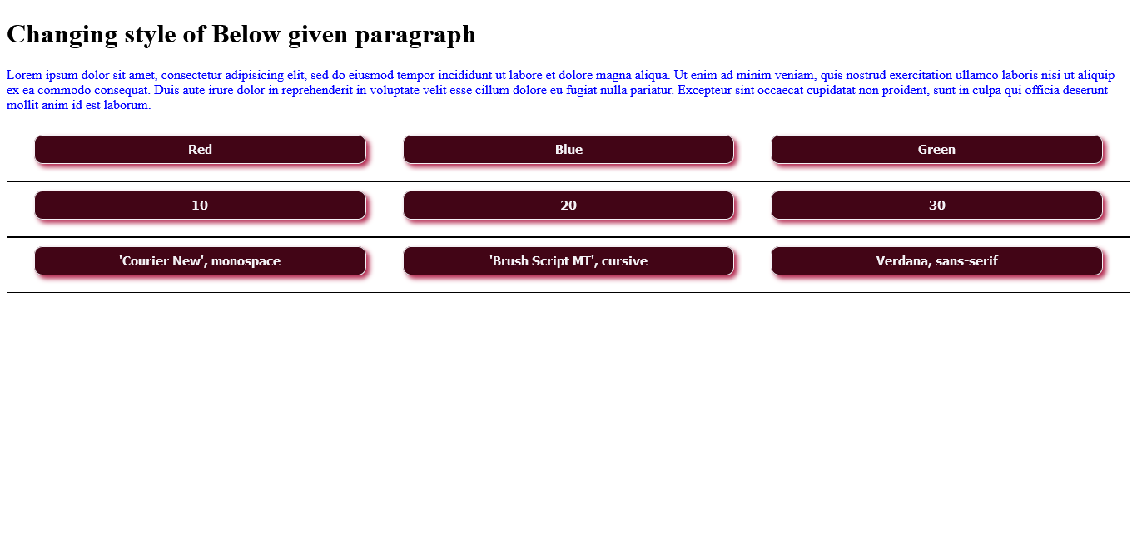

6.Create a form that takes data about a pet. The form must be well designed and should accept the pet's name, age, weight, type, and what it likes most. At the submission of this form create a Pet object in JavaScript filled with these values and log that object and equivalent JSON on the console.

<!DOCTYPE html>

<html>

<head>

<meta charset="utf-8">

<title>Practical 6</title>

<style type="text/css">

.container{

width: 60%;

margin: auto;

border: 1px solid black;

border-radius: 8px;

padding: 50px;

}

.btn-submit{

border-radius: 5px;

color: white;

background: greenyellow;

font-weight: bold;

font-size: 1rem;

margin: 20px;

}

@media(width<=575){

.container{

width: 84%;

}

}

</style>

</head>

<body>

<div class="container">

<h1>Pet's Information</h1>

<hr>

<label for="name">Pet's Name: </label>

<input type="text" name="name"><br><br>

<label for="age">Age: </label>

<input type="number" name="age">

<label for="weight">Weight: </label>

<input type="number" name="weight" class=""><br><br>

<label for="type">Pet type: </label>

<input type="text" name="type"><br><br>

<label for="likes">Likes: </label>

<input type="text" name="likes"><br>

<button class="btn-submit" onclick="display()">Submit</button>

</div>

<script type="text/javascript">

function display(){

// event.preventDafault();

var pet = {};

var input_fields = document.getElementsByTagName('input');

for (var i = 0; i < input_fields.length; i++) {

pet[input_fields[i].name] = input_fields[i].value;

}

console.log(pet);

}

</script>

</body>

</html>

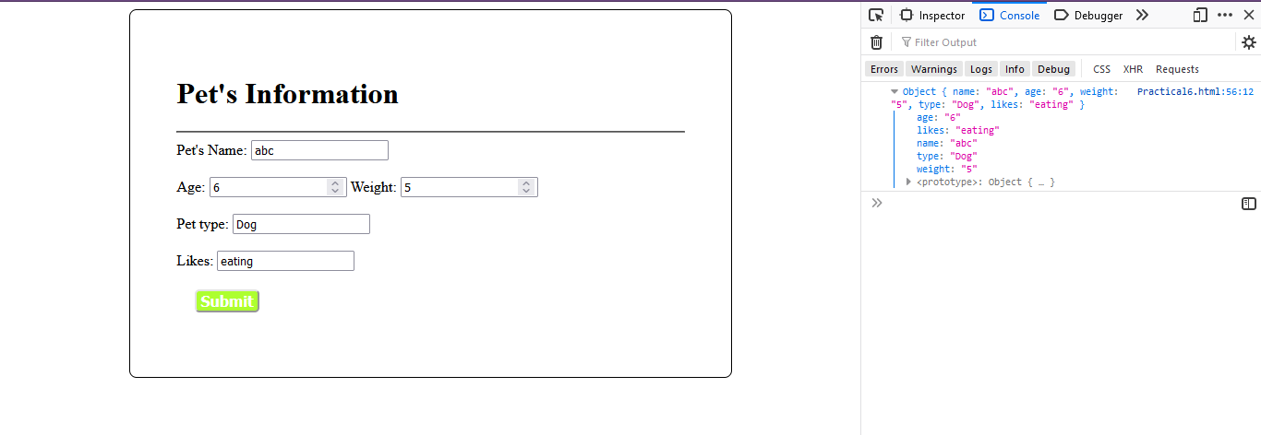

7.Store JSON data of few pets that you created in previous practical in a JSON file (copy from console output of previous program to a .json file). Using AJAX, load data from the file and display it in a presentable way using HTML and CSS.

<!DOCTYPE html>

<html>

<head>

<meta charset="utf-8">

<title>Practical 7</title>

<style type="text/css">

#pet-data{

border: 1px solid black;

border-radius: 10px;

border-collapse: collapse;

}

td{

border: 1px solid black;

border-collapse: collapse;

}

#btn-fetch{

margin-top: 20px;

font-size: 24px;

font-weight: bold;

background-color: black;

color: white;

border-radius: 8px;

}

</style>

</head>

<body>

<div id="content">

</div>

<button id="btn-fetch">Fetch Data</button>

<script src="https://ajax.googleapis.com/ajax/libs/jquery/3.5.1/jquery.min.js"></script>

<script type="text/javascript">

var btnFetch = document.getElementById('btn-fetch');

var content = document.getElementById('content');

btnFetch.addEventListener('click', ()=>{

const xhr = new XMLHttpRequest();

xhr.open("GET",'/pet.json',true);

xhr.onload = ()=>{

console.log(xhr.responseText);

renderHtml(JSON.parse(xhr.responseText));

}

xhr.send();

});

function renderHtml(data){

content.innerHTML = "";

for (var i = 0; i <= data.length; i++) {

let p = document.createElement('p');

let htmlpart = "";

htmlpart += data[i].name+" is a "+data[i].type+" with age "+data[i].age+" years and weight "+data[i].weight+"kg and likes "+data[i].likes;

p.innerHTML = htmlpart;

content.append(p);

htmlpart="";

}

}

</script>

</body>

</html>

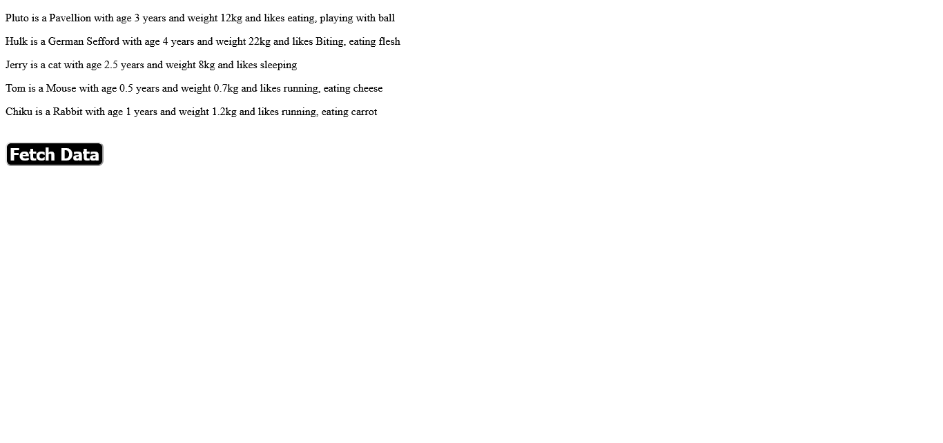

Pet.json file

[

{

"name":"Pluto",

"age":3,

"weight":12,

"type":"Pavellion",

"likes":"eating, playing with ball"

},

{

"name":"Hulk",

"age":4,

"weight":22,

"type":"German Sefford",

"likes":"Biting, eating flesh"

},

{

"name":"Jerry",

"age":2.5,

"weight":8,

"type":"cat",

"likes":"sleeping"

},

{

"name":"Tom",

"age":0.5,

"weight":0.7,

"type":"Mouse",

"likes":"running, eating cheese"

},

{

"name":"Chiku",

"age":1,

"weight":1.2,

"type":"Rabbit",

"likes":"running, eating carrot"

}

]

8.Create a plain HTML page for B.Sc. Hons CS course, mentioning details like fee, eligibility criteria, papers with names and credits, and future possibilities after the course. A button for styling should be there at bottom of the page. On clicking on this button JavaScript should redesign the complete page using jQuery in a nice presentable way.

<!DOCTYPE html>

<html>

<head>

<meta charset="utf-8">

<title>Practical 8</title>

<style type="text/css">

.container{

width: 70%;

margin: auto;

align-items: center;

background-color: #D9CAB3;

padding-bottom: 10px;

}

.info-table{

width: 80%;

margin: auto;

border: 3px solid black;

border-collapse: collapse;

margin-top: 2%;

margin-bottom: 2%;

}

.table-row{

width: 100%;

margin: auto;

}

.table-data{

width: 50%;

border: 2px solid white;

border-collapse: collapse;

}

</style>

</head>

<body>

<div>

<h1 class="heading">Bsc Hons Computer Science</h1>

<table>

<tr>

<td>Fee</td>

<td>25644</td>

</tr>

<tr>

<td>Eligibility Criteria</td>

<td>10-12 Pass</td>

</tr>

<tr>

<td>Subjects and credit scores</td>

<td>

<table>

<tr>

<th>Subject</th>

<th>Credit score</th>

</tr>

<tr>

<td>IT</td>

<td>6</td>

</tr>

<tr>

<td>Toc</td>

<td>6</td>

</tr>

<tr>

<td>DAV</td>

<td>4</td>

</tr>

<tr>

<td>DIP/Micro</td>

<td>4</td>

</tr>

</table>

</td>

</tr>

<tr>

<td>Future Opportunities</td>

<td>Bohot scope h isme</td>

</tr>

</table>

</div>

<button id="btn-style">

Style Page

</button>

<script src="https://ajax.googleapis.com/ajax/libs/jquery/3.5.1/jquery.min.js"></script>

<script type="text/javascript">

$(document).ready(function(){

$('#btn-style').click(function(){

$("div").addClass('container');

$("table").addClass('info-table');

$("tr").addClass('table-row');

$("td").addClass('table-data');

$(".heading").css({

"textAlign":'center'

});

});

});

</script>

</body>

</html>

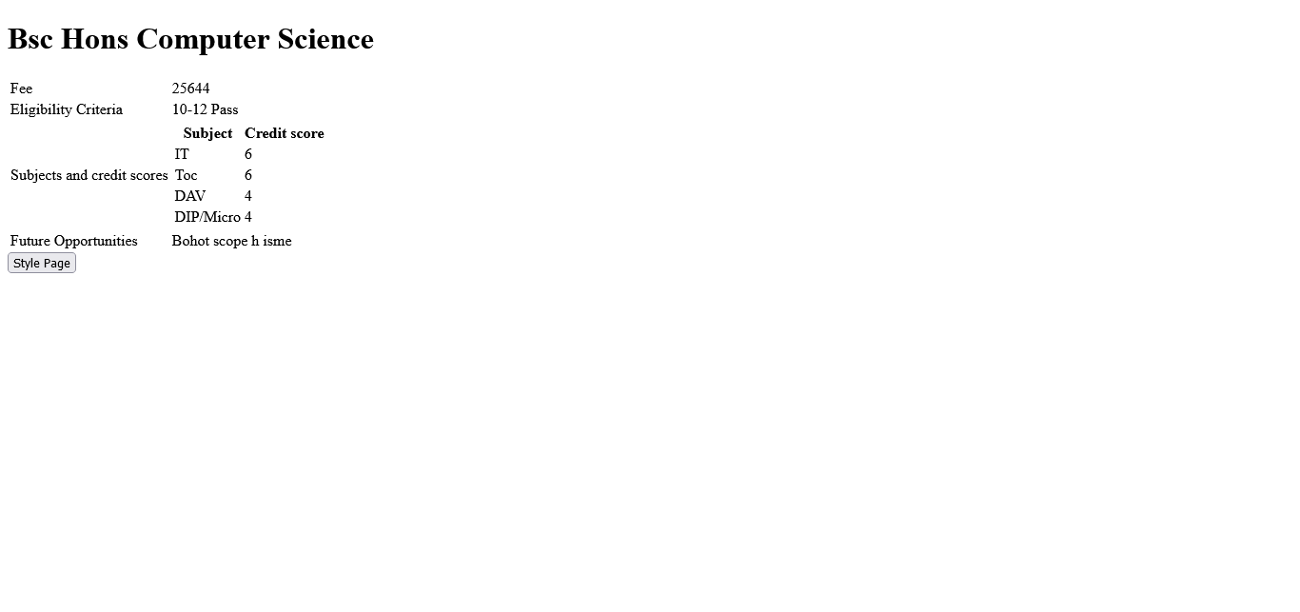

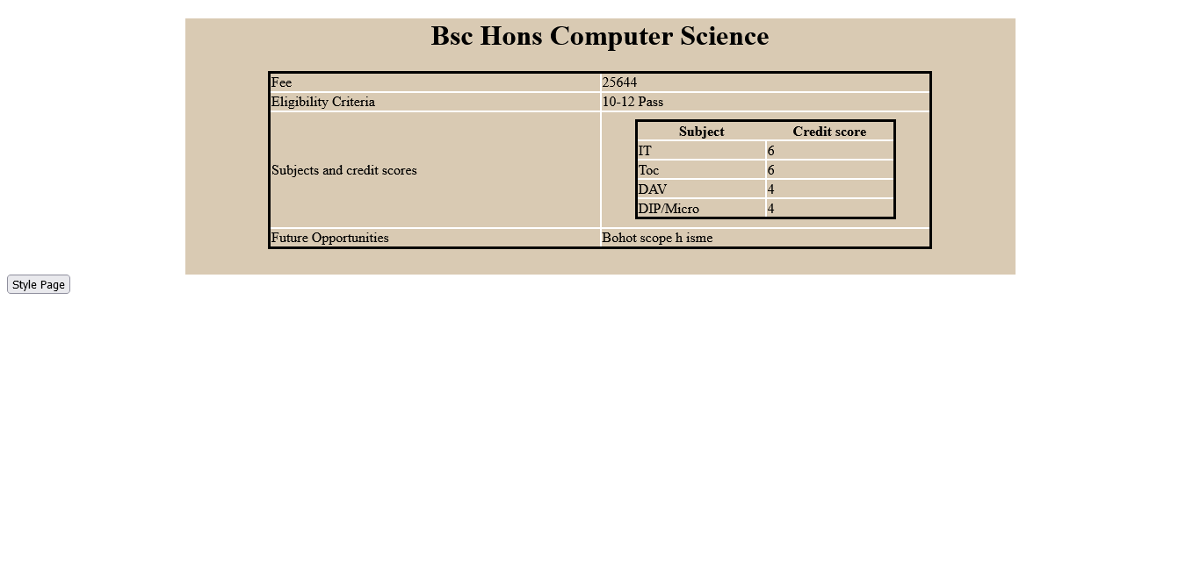

9.Create an HTML page for an image gallery which shows the use of BOOTSTRAP to rearrange and resize its contents on resizing the browser.

<!DOCTYPE html>

<html>

<head>

<meta charset="utf-8">

<meta name="viewport" content="width=device-width, initial-scale=1">

<link rel="stylesheet" href="https://maxcdn.bootstrapcdn.com/bootstrap/3.4.1/css/bootstrap.min.css">

<title>Practical 9</title>

<style type="text/css">

/*img{

margin: 20px;

}*/

</style>

</head>

<body>

<div class="jumbotron text-center">

<h1>IMAGE GALLERY</h1>

<p>Responsive Image gallery using bootstrap.</p>

</div>

<div class="container">

<img class="col-sm-4" src="https://picsum.photos/200/"></img>

<img class="col-sm-4" src="https://picsum.photos/200/"></img>

<img class="col-sm-4" src="https://picsum.photos/200/"></img>

<img class="col-sm-4" src="https://picsum.photos/200/"></img>

<img class="col-sm-4" src="https://picsum.photos/200/"></img>

<img class="col-sm-4" src="https://picsum.photos/200/"></img>

</div>

<script src="https://ajax.googleapis.com/ajax/libs/jquery/3.5.1/jquery.min.js"></script>

<script src="https://maxcdn.bootstrapcdn.com/bootstrap/3.4.1/js/bootstrap.min.js"></script>

</body>

</html>

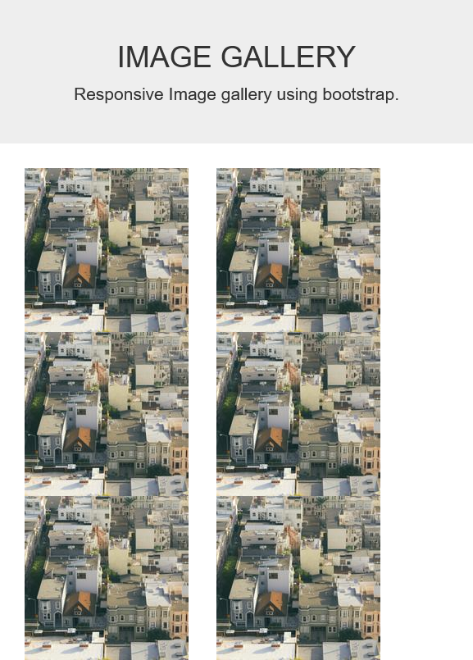

10.Create an HTTP server using Node.js which handles requests on port 10000 or a free port beyond 10000. Modify the server in such a way that opening localhost:10000 will display "Hello World, This is my MOde.js server" on browser.

var http = require('http');

http.createServer((request,response)=>{

response.write("Hello World, This is my Node.js server");

response.end();

})

.listen(10000,()=>console.log('server started at port 10000'));

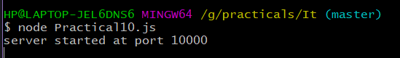

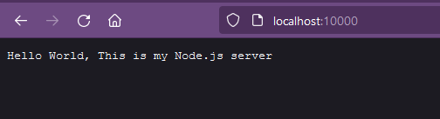

**Practice Questions**

1.Create an Javascript array and Perform Push and Pull Methods.

<!DOCTYPE html>

<html>

<head>

<meta charset="utf-8">

<title>Practice Ques 1</title>

<style type="text/css">

.container{

width: 50%;

align-items: center;

margin: auto;

margin-top: 40px;

border: 1px solid black;

border-radius: 5px;

padding: 3%;

padding-left: 10%;

}

input[name='element'],.output{

height: 20px;

width: 60%;

}

#btn-push,#btn-pop,#btn-reset{

width: 25%;

margin-top: 10px;

height: 25px;

margin-right: 3%;

font-weight: bold;

font-size: 15px;

}

.output{

margin-top: 15px;

border: 1px solid black;

border-radius: 5px;

min-height: 150px;

}

</style>

</head>

<body>

<div class="container">

<input type="text" name="element"/>

<br/>

<button id="btn-push">Push</button>

<button id="btn-pop">Pop</button>

<div class="output">

The entered array is:-

<p id="screen">

</p>

</div>

<button id="btn-reset">Reset</button>

</div>

<script type="text/javascript">

var ar = [2,3,4];

var screen = document.getElementById('screen');

var btnpush = document.getElementById('btn-push');

var btnpop = document.getElementById('btn-pop');

var btnreset = document.getElementById('btn-reset');

var element = document.querySelector('input[name="element"]');

function displayOutput(operation=null){

var out;

if (operation){

var opr;

out = "Previous Array:- "+ar.join(" ")+"<br>";

if (operation === 'push') {

var temp = element.value;

if(temp){

ar.push(temp);

opr="Element "+temp+" has been pushed to Array";

}

opr = "Input Field is Empty!!";

}

else if(operation === 'pop'){

opr="Element "+ar.pop()+" has been popped out of Array";

}

element.value = "";

element.focus();

out+="Operation:- "+opr+"<br>New Array:- "+ar.join(" ");

}

else{

ar = [];

out="There is no element in the array";

}

screen.innerHTML=out;

}

btnreset.addEventListener('click',function(){

displayOutput();

});

btnpush.addEventListener('click',function(){

displayOutput('push');

});

btnpop.addEventListener('click',function(){

displayOutput('pop');

});

displayOutput();

</script>

</body>

</html>

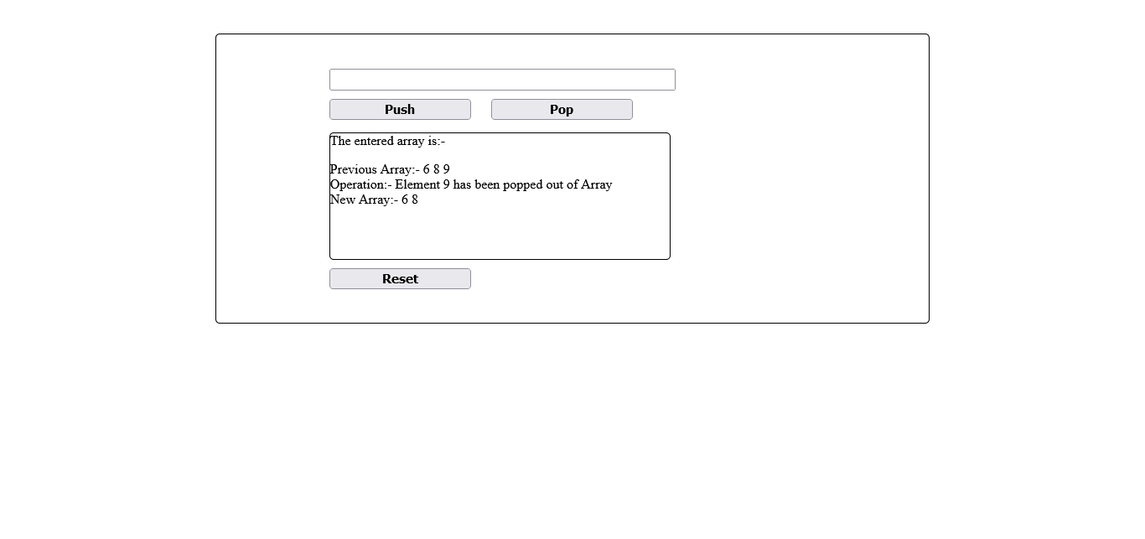

2. Check if the input string in input file is numerical value or character Value.

<!DOCTYPE html>

<html>

<head>

<meta charset="utf-8">

<title>Practice Ques 2</title>

<style type="text/css">

.container{

width: 50%;

align-items: center;

margin: auto;

margin-top: 40px;

border: 1px solid black;

border-radius: 5px;

padding: 3%;

padding-left: 10%;

}

input[name='element'],.output{

height: 20px;

width: 60%;

}

#btn-push,#btn-pop,#btn-reset{

width: 25%;

margin-top: 10px;

height: 25px;

margin-right: 3%;

font-weight: bold;

font-size: 15px;

}

.output{

margin-top: 15px;

border: 1px solid black;

border-radius: 5px;

min-height: 150px;

}

</style>

</head>

<body>

<div class="container">

<input type="text" name="element"/>

<br/>

<div class="output">

Output Panel:-

<p id="screen">

</p>

</div>

<button id="btn-reset">Reset</button>

</div>

<script type="text/javascript">

var screen = document.getElementById('screen');

var btncheck = document.getElementById('btn-check');

var btnreset = document.getElementById('btn-reset');

var element = document.querySelector('input[name="element"]');

function displayOutput(operation=null){

var out;

if (operation){

var opr;

if (operation === 'check') {

var temp = element.value;

if(temp){

if(temp.match(/^\d*$/))

{

out = "Number";

}

else{

out = "String";

}

}

else{

out = "Input Field is Empty!!";

}

}

element.value = "";

element.focus();

}

else{

out = "Enter something in Input field to check";

}

screen.innerHTML=out;

}

btnreset.addEventListener('click',function(){

displayOutput();

});

element.addEventListener('change',function(){

displayOutput('check');

});

displayOutput();

</script>

</body>

</html>

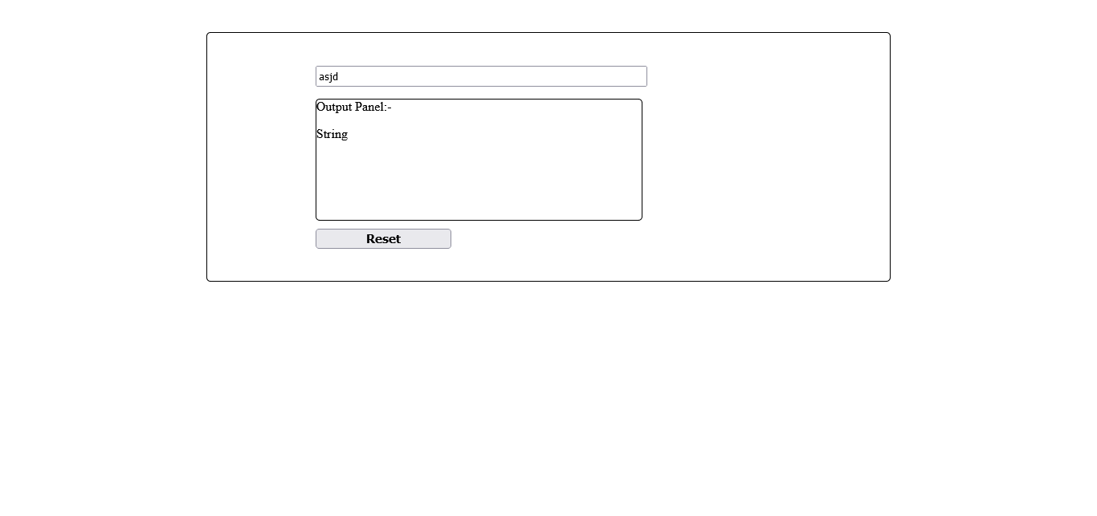

3. Create a Digital Clock using Java script.

<!DOCTYPE html>

<html>

<head>

<meta charset="utf-8">

<meta name="viewport" content="width=device-width, initial-scale=1.0">

<title>Digital Clock</title>

<style type="text/css">

.container{

font-size: 36px;

background-color: #152D35;

color: white;

display: inline-block;

margin-left: 45%;

margin-top: 2%;

border-radius: 8px;

padding: 4px;

}

.timer{

margin: 0px;

}

</style>

</head>

<body>

<div class="container">

<p class="timer">00:00:00</p>

</div>

<script type="text/javascript">

var timer = document.querySelector('.timer');

setInterval(async function(){

var d = new Date();

timer.innerHTML= d.getHours()+":"+d.getMinutes()+":"+d.getSeconds();

},1000);

</script>

</body>

</html>

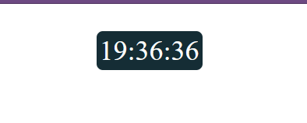

4. Make a Add more button to create duplicate of the input field or make it multiple.

<!DOCTYPE html>

<html>

<head>

<meta charset="utf-8">

<title>Add Mutiple</title>

</head>

<body>

<h1>Adding Multiple Fields Dynamically</h1>

<div>

<div>

<label for="name">Your Name: </label>

<input type="text" name="name" placeholder="Your Name Here">

</div>

</div>

<button class="add_btn">Add More fields</button>

<script src="https://ajax.googleapis.com/ajax/libs/jquery/3.5.1/jquery.min.js"></script>

<script type="text/javascript">

$(document).ready(function() {

$(".add_btn").click(function(e){

temp=$(this).siblings("div");

var x =$(this).siblings("div").children()[0].cloneNode(true);

// x.innerHTML ='abc';

let removeButton = document.createElement('Button');

removeButton.className='remove_btn';

removeButton.textContent='Remove';

var attr = document.createAttribute('onclick');

attr.nodeValue='removeItem()';

removeButton.setAttributeNode(attr);

x.append(removeButton);

temp.append(x);

console.log(x);

});

});

function removeItem(){

// var x = ;

// console.log(x);

// x.remove();

}

</script>

</body>

</html>

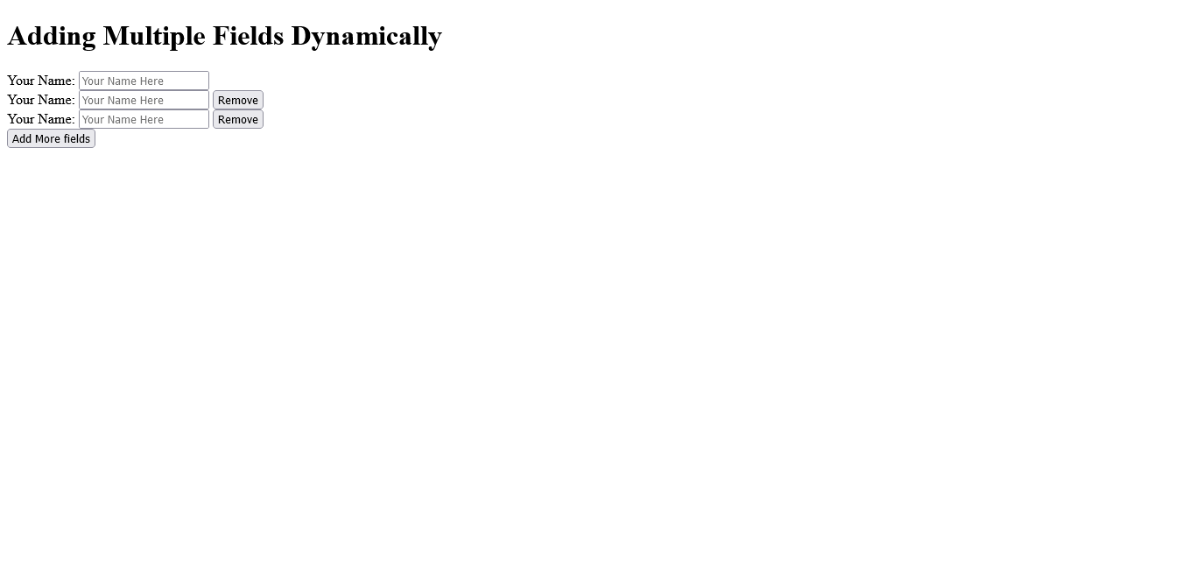

5. Moving image effect using Javascript.

<!DOCTYPE html>

<html>

<head>

<meta charset="utf-8">

<title>Moving Image</title>

<style type="text/css">

.container{

width: 100%;

padding: 0px;

margin: 0px;

}

.container img{

padding: 0px;

margin: 0px;

}

#btn-stop, #btn-start{

font-size: 18px;

font-weight: bold;

color: white;

margin-left: 2%;

border-radius: 10px;

min-width: 10%;

margin-top: 1rem;

}

#btn-stop{

background-color: red;

}

#btn-start{

background-color: green;

}

</style>

</head>

<body>

<h1>Moving Image Web page using javascript</h1>

<div class="container">

<img src="https://picsum.photos/200/">

</div>

<button id="btn-start">Start</button>

<button id="btn-stop">Stop</button>

<script type="text/javascript">

var image = document.querySelector('.container img');

var container = document.querySelector('.container');

function movingImage(){

leftMargin = Number(image.style.marginLeft.split('px')[0]);

if(leftMargin+image.offsetWidth<=container.offsetWidth)

{

image.style.marginLeft = leftMargin+10+"px";

}

else{

image.style.marginLeft = "0px";

}

}

var abc = setInterval(movingImage,200);

var btnStop = document.getElementById('btn-stop');

var btnStart = document.getElementById('btn-start');

btnStop.addEventListener('click',()=>{

clearInterval(abc);

});

btnStart.addEventListener('click',()=>{

abc = setInterval(movingImage,200);

});

</script>

</body>

</html>

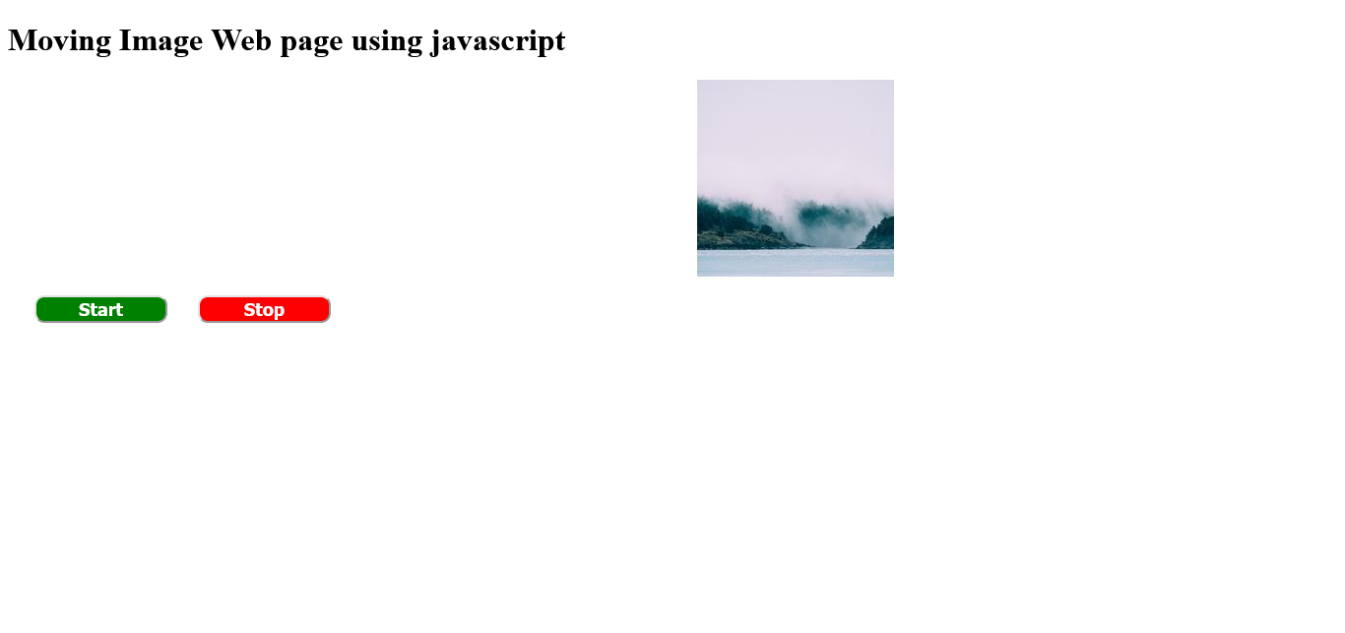

6. Increase and decrease the size of image as mouse pointer enter the image section or leaves it.

<!DOCTYPE html>

<html>

<head>

<meta charset="utf-8">

<title>Mouse Event</title>

<style type="text/css">

img{

width: 200px;

height: 200px;

}

</style>

</head>

<body>

<h1>Mouse Event web page</h1>

<img id="event-img" src="https://picsum.photos/200/">

<script type="text/javascript">

var image = document.getElementById('event-img');

image.addEventListener('mouseenter',()=>{

image.style.width = "400px";

image.style.height = "400px";

});

image.addEventListener('mouseleave',()=>{

image.style.width = "200px";

image.style.height = "200px";

});

</script>

</body>

</html>

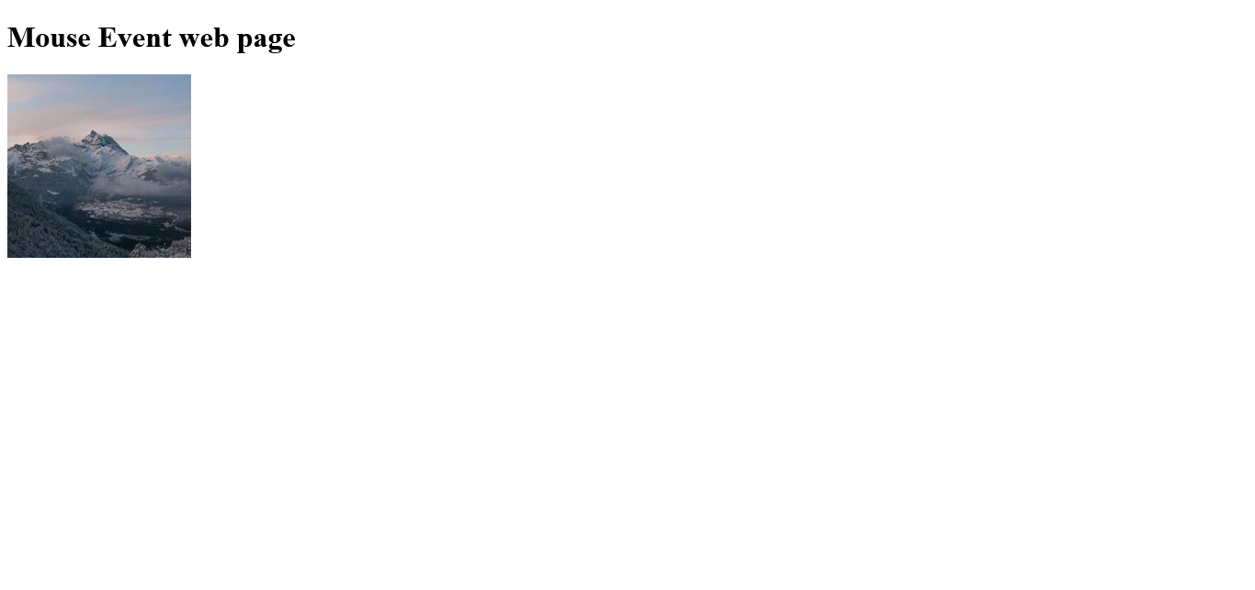

**Thank You!**